**Sree Vidyanikethan Engineering College**

**(AUTONOMOUS)**

Sree Sainath Nagar, A. Rangampet –517102.

**I B.Tech II Semester (SVEC-19) Mid-I Examinations, June - 2020**

**(19BT10531) PROGRAMMING FOR PROBLEM SOLVING Lab**

**(Common to ECE,EEE and EIE)**

Question 1

**Which of the following functions are used to retrieve the ASCII value of a given character of a string**

A)chr()

B)ord()

C)id()

D)type()

Question 2

**Which of the following is not a valid data type in Python**

A) str

B) int

C) float

D) double

Question 3

**Identify the wrong arithmetic operator from the following**

A) **

B) //

C) ++

D) +

Question 4

**Predict the output of the following statement: a=23<<2**

A) 192

B) 92

C) 94

D) 91

Question 5

**Predict the output for following program**



A) 1 to 10

B) 1 to 9

C) 1 to 9 all odd numbers

D) 0 to 9

Question 6

**Predict the output for following program**

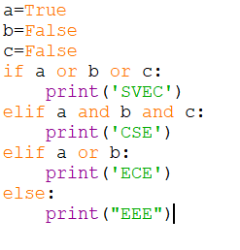

A) CSE

B) EEE

C) ECE

D) SVEC

Question 7

**Which of the following is an invalid statement**

A) a_b_c=100

B) a,b,c=10,20,30

C) a,b=10

D) a,b=10,20,30

Question 8

**What is the output of this expression 2**3+2*4**

A) 16

B) 40

C) 30

D) 120

Question 9

**Select the symbol used for decision making in flowchart.**

A)

B)

C)

D)

Question 10

**Predict the output for following program**

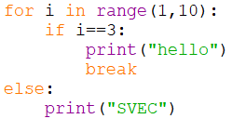

A) hello

B) SVEC

C) hello, SVEC

D) 3 times hello

Question 11

**Predict the output for following program**

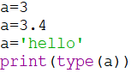

A) <class 'int'>

B) <class 'str'>

C) <class 'float'>

D) None

Question 12

**Predict the output for following program**

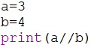

A) 0

B) 0.75

C) 0.0

D) None

Question 13

**Which of the following statement used to represent empty blocks in python.**

A) break

B) pass

C) continue

D) goto

Question 14

**Select the control statement which will not work in python**

A) if

B) while

C) switch

D) break

Question 15

**Select the membership operator**

A) and

B) in

C) is

D) <

Question 16

**Input() will read**

A) complete line at a time

B) only one word

C) only one character

D) multiple lines at a time

Question 17

**a='0b1100', which of the following statement is correct to convert given binary string in to decimal number.**

A) int(a)

B) int(a,2)

C) bin(a)

D) None

Question 18

**Predict the output for following program**

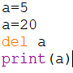

A) error at print statement

B) 5

C) 20

D) 25

Question 19

**Which of these is not a core data type**

A) list

B) tuple

C) class

D) int

Question 20

**Which of the following statement terminates the loop statement and transfers execution to the statement immediately following the loop?**

A) continue

B) break

C) pass

D) None